**Introduction and background**

SiC particle reinforced Al matrix composites, as lightweight novel materials, have a controllable coefficient of thermal expansion (CTE) and thermal conductivity (TC) and excellent corrosion resistance properties. They are thus attracting great attention from both academic and industrial communities [1]. Traditional methods for producing Al-SiC composites such as powder metallurgy [2], casting [3] and infiltration [4], face a lot of difficulties when used for the fabrication of components with complex structures. Selective laser melting (SLM) is an emerging additive manufacturing technology that has been predominantly used for the production of metal-based components with complex geometry and high dimensional accuracy [5]. This 3D printing technology breaks the bottleneck of complex-structure manufacturing, providing a new path for producing customized Al-SiC composite materials.

Despite promising, the fabrication of Al-SiC composites with SLM is still facing considerable challenges: 1) The high reflectivity and high reactivity with oxygen of Al significantly increase the manufacturing difficulties; 2) The unfavorable flowability of Al-SiC powder mixture adds further difficulty to the manufacturing; 3) The poor wettability of liquid Al on the surface of SiC powders may lead to an inhomogeneous distribution of SiC in Al-SiC composites; 4) The reaction between Al and SiC will produce unfavorable Al4C3 phase when processing temperature is higher than 933K, which may result in the formation of defects (e.g., cracks and pores) in Ai-SiC composites. To date, a number of works with regard to SLM Al-SiC composites have been done so as to solve the aforementioned problems. Previous studies have reported that the formability of SLM Al matrix composites became gradually stable and the formation of unfavorable Al4C3 was gradually restrained as the content of Si increased. Therefore, higher Si content is beneficial to the processing of Al matrix composites with SLM. Apart from this, higher Si content is also known to resulte in lower CTE, which enables the Al-SiC composites suitable for the application in electronic industries. However, if the Si content is beyond a critical value (>12.6%), primary Si with irregular shape and coarse size may form in the Al-SiC composite, deteriorating the mechanical properties of the Al-SiC composite.

Al-20Si composites with low density, high TC and excellent fatigue properties have great potentials to be applied in automobile and electronic industries. Studies also demonstrated that Al-20Si is a candidate material for SLM due to its proper Si content. However, to date, several key issues related to the optimized processing parameters, strengthening mechanism and property improvement strategies of SLM Al-20Si composites have not been fully understood. The proposed PhD project aims to provide an in-depth investigation of these unclear issues through experiments and numerical modeling. Successful implementation of this project will fully unveil the best manufacturing strategies for SLM Al-20Si composites and will promote its applications in electronic industries.

**Methodology:**

The project will be divided into five major work packages

1. Processing parameter optimization of SLM Al-20Si alloy;

* Exploring the optimized processing parameters (i.e., laser powder, layer thickness, hatch distance, spot size and scanning strategy) through experiments. The evaluation criteria are low porosity and high properties.
* The surface conditions and internal defects will be evaluated.
* The mechanical properties (tensile strength and ductility) and thermal properties (CTE and TC) of each sample will be tested and linked with the corresponding microstructures.

1. Refinement of primary Si in SLM Al-20Si alloy

* Electron backscattering diffraction (EBSD) will be used for characterizing the refined primary Si (i.e., size, morphology and amount).
* Mechanical and thermal properties of the samples will be tested.
* The relationship between the size of the primary Si and TC will be established.

1. In-depth investigation of strengthening mechanism

* The influence of SiC particle size on the mechanical and thermal properties.
* The strengthening mechanism (e.g., Orowan and dislocation strengthening) will be discussed.
* Investigation into the possible Al4C3 phase to explore an effective method to prevent its formation.

1. Surface modification of SiC powders to prevent Al-SiC reaction

* Metal-coated (e.g., Ni and Ti) SiC will be applied as the reinforcing particles to prevent the direct contact between Al and SiC.
* The effect of metal layer thickness and metal type on the properties of SLM Al-SiC composites.
* The interfacial energy between Al, interlayer, and SiC will be studied.

1. Numerical simulation of molten pool through Computational Fluid Dynamics (CFD)

* Establishing the numerical model of molten pool to simulate the characteristic of flow and heat transfer and improving the model by comparing with the experimental result.
* Exploring the influence of different processing parameters (i.e. laser power, laser powder, layer thickness, hatch distance, spot size and scanning strategy) on the characteristic of flow and heat transfer and surface topography of molten pool.
* Analyzing the formation mechanism of porosity defects according to the solute flow and gas-liquid interface behavior in molten pool so as to optimize the experimental parameters.

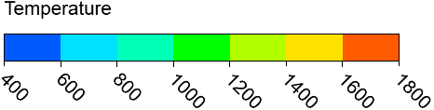

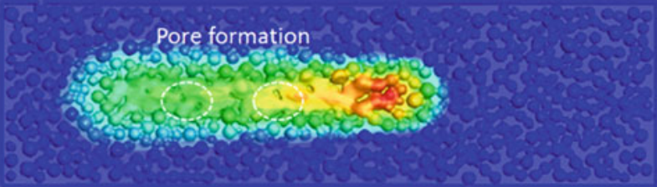

[1] C.S. Jawalkar, A. Singh, N.M. Suri, Fabrication of Aluminium Metal Matrix Composites with Particulate Reinforcement : A Review, Mater. Today Proc. 4 (2017) 2927–2936.

[2] O. El-Kady, A. Fathy, Effect of SiC particle size on the physical and mechanical properties of extruded Al matrix nanocomposites, Mater. Des. 54 (2014) 348–353.

[3] C. Guo-qin, X.I.U. Zi-yang, M. Song-he, Thermal expansion and mechanical properties of high reinforcement content SiC p / Cu composites fabricated by squeeze casting technology, Trans. Nonferrous Met. Soc. China. 19 (2009) s600–s604.

[4] B. Xiong, H. Yu, Z. Xu, Fabrication of SiC particulate reinforced AZ91D composite by vacuum-assisted pressure infiltration technology, J. Alloys Compd. 509 (2011) L279–L283.

[5] A. Bandyopadhyay, B. Heer, Additive manufacturing of multi-material structures, Mater. Sci. Eng. R Reports. 129 (2018) 1–16.